Day 20: 11-11-2025:

Spring boot with mongo db relationship linking style
Product and orders : one product we can place many orders.
Starter Web Starter
Starter mongo db starter
Starter devtool (this starer help us to re fresh whenever we do any changes in running application).

Micro Service:
Micro service means small service doing specific task rather than whole application.

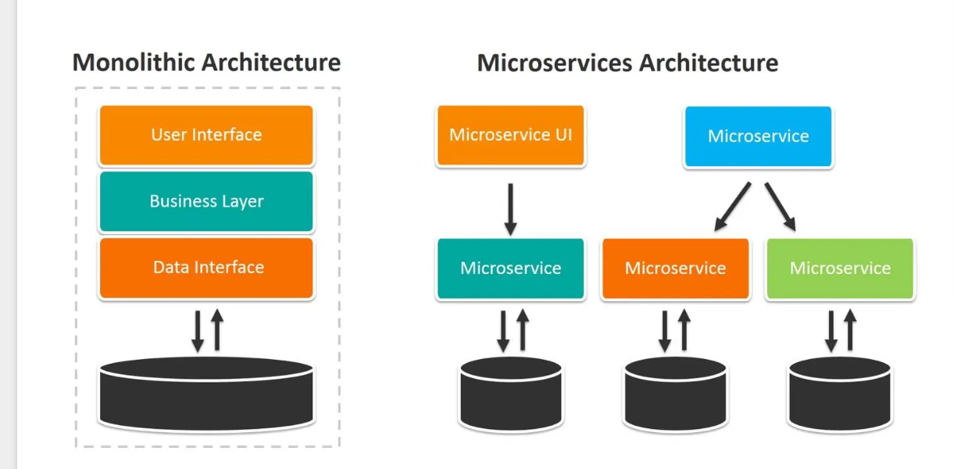

Login module, Customer module, payment module, account module
1 team - login module
2 team customer module
3 team payment module
All these modules develop using same language
Same database
Each team depends upon other team to make final project.
After all team work done we need to create final build file ie jar or war file and deploy in server.
If any features any changes required in particular module we need to the changes and re-deploy whole application once again.
If any issue happen in any other the whole application doesn’t work.
We need take help any language features.

Monolithic service means in this approach we write all layer or tier using same language
Limitation of monolithic service
- View layer, controller layer, bean layer, service layer, dao or repository and database using same language.
- You must use same database.

A micro service is a small, independent and self contained application which deploy independent develop using same language or different language, using same database or different database and deploy on different port number.
In micro service you need to focus on small task rather than whole project.
These all application interact with each other using rest api call.

To achieve micro service using spring boot. Spring provided one of the module
Spring cloud
This module contains pre defined service or service registry ie Eureka Server.
Eureka Server: it is a type of registry or server which help to deploy more than one micro service created using Java language as well as other language.
Eureka Server is a part of Netflix.
Eureka server keep the track, maintain the life the each micro service.
1st Eureka Server
To create Eureka Server
Starter Eureka Starter
Starter Web starter

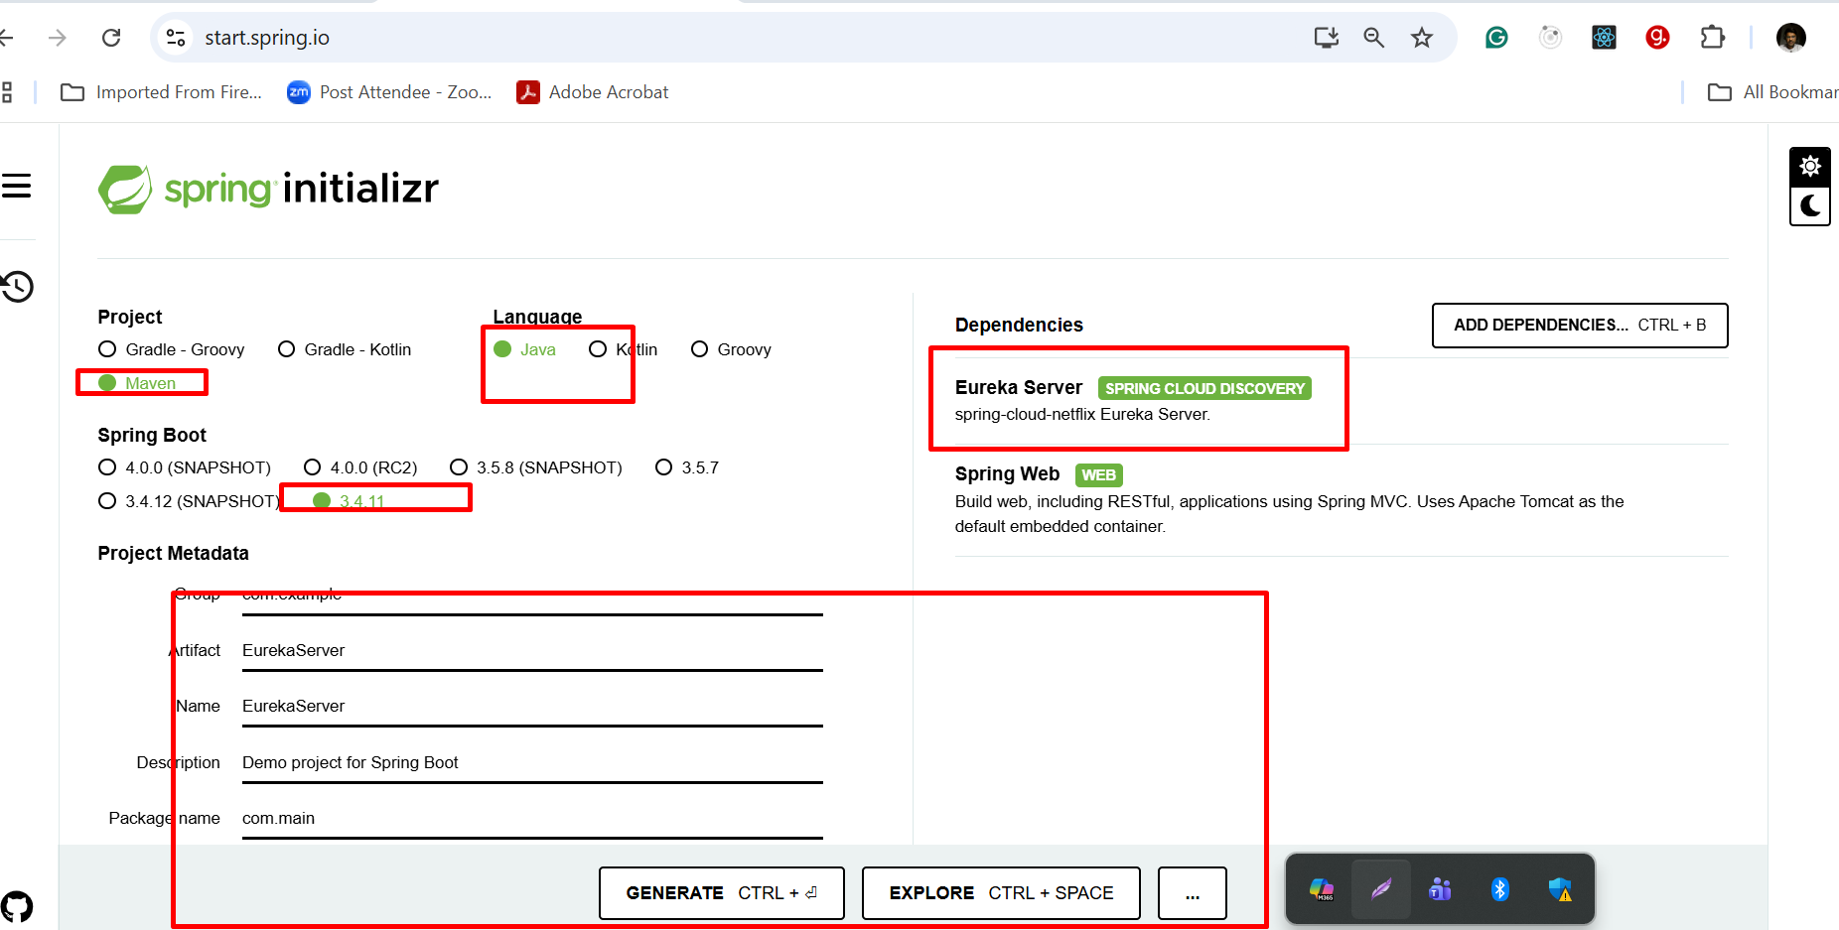

By default each micro service project search eureka server on default port number 8761.

2nd project: Simple Rest API : port number 8080

Starter - Web Starter
Starter Eureka Discovery client : this starter help us to deploy this project on Eureka Server.

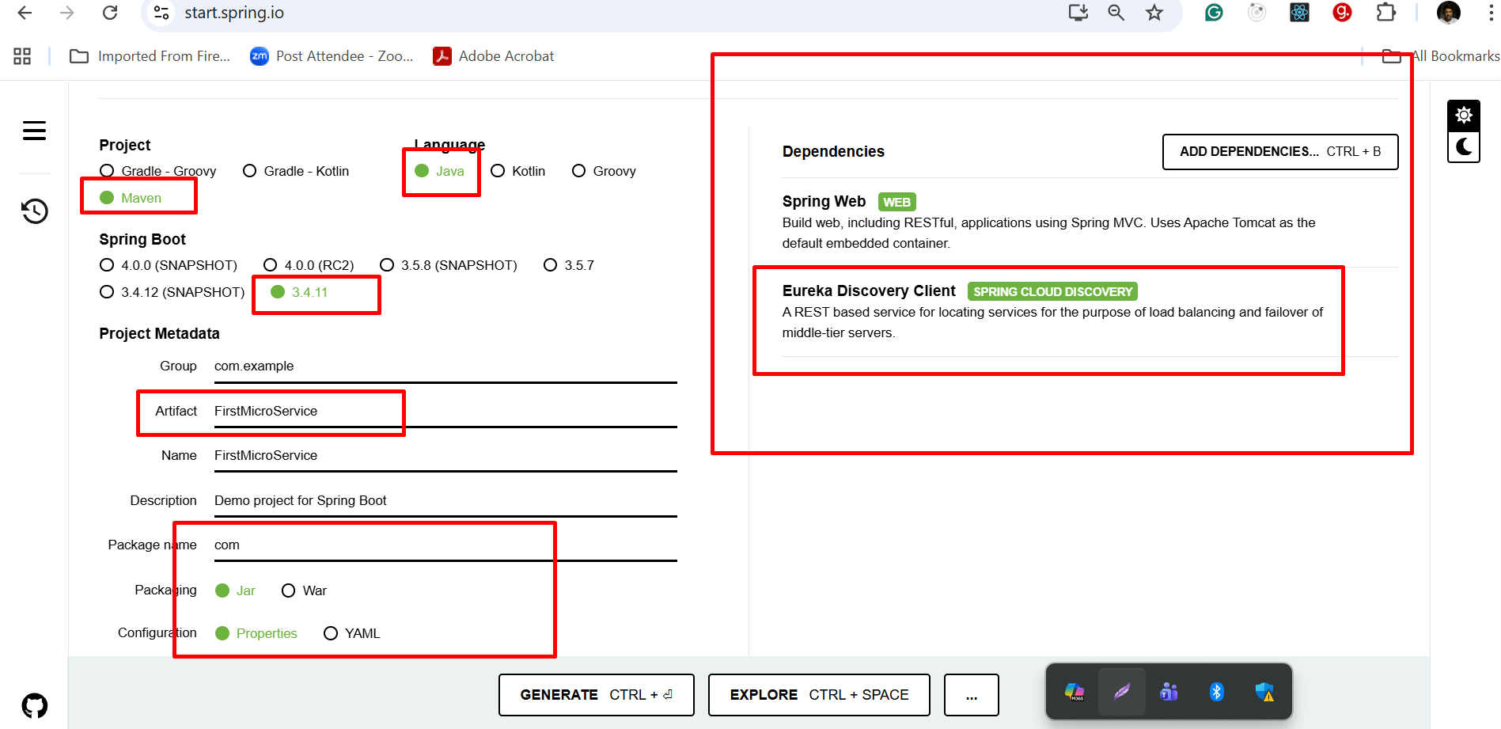

@EnableDiscoveryClient : Add this annotation on main class. It check eureka server running same machine with default port number 8761. If present it deploy this project or register this project with Eureka Server.
Base upon rest api we can consume those rest api using post man client.

3rd project : Simple Rest API : port number 8181
Starter - Web Starter
Starter Eureka Discovery client

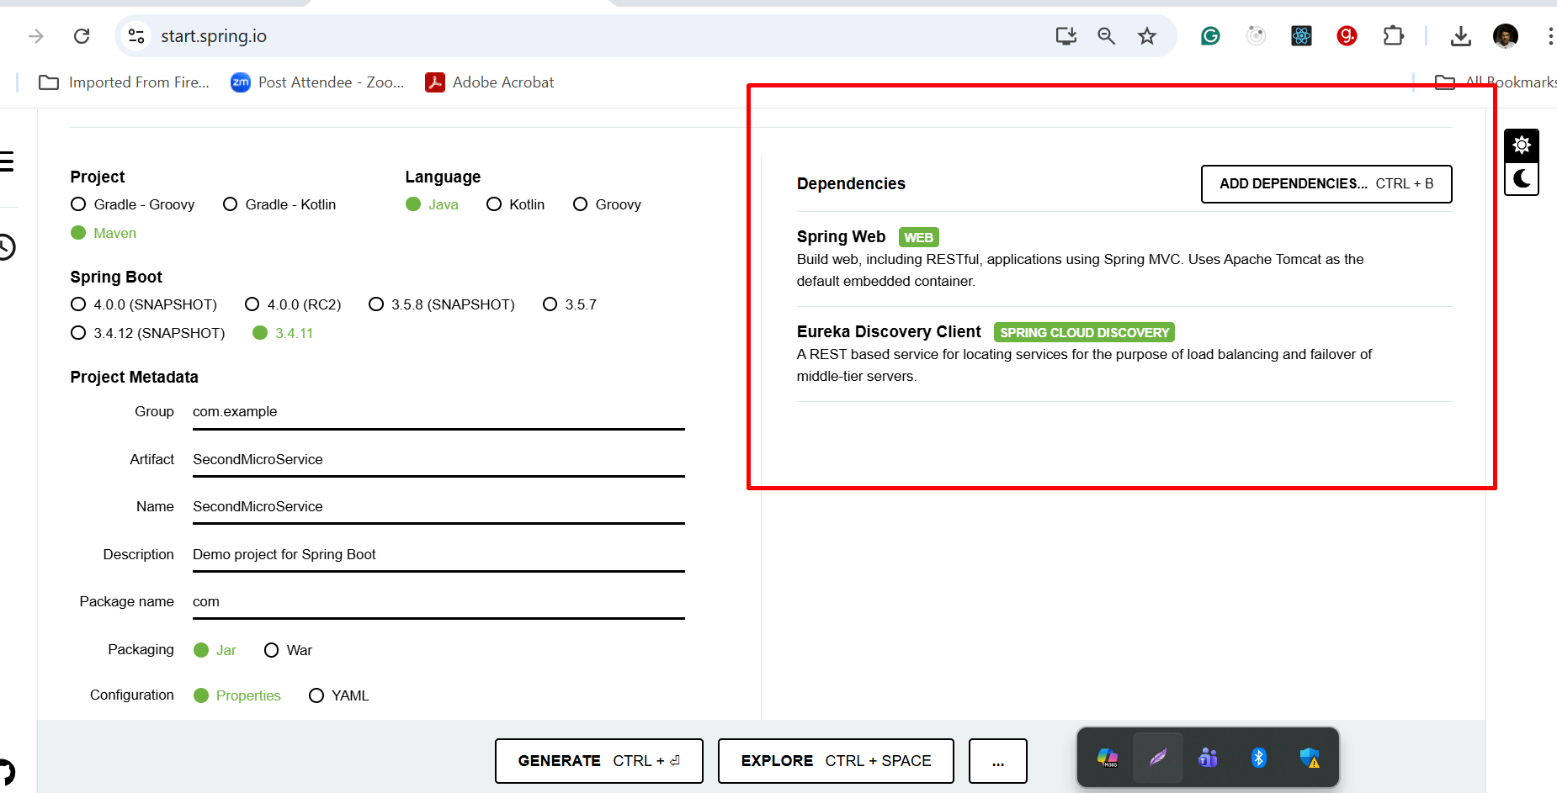

3rd micro service project port number 8282
Starter Web Starter
Starter JPA starter
Dependency MySQL Connector
Starter Eureka Discovery client

application.properties file
Mysql database connection details

It provide account related end point
Accno PK
Name
Amount
Emaild Unique

Post method account create
Get method find balance using accno with path param
Custom query
Using emailId find the balance
Using emailId find account number

